** Department of Economics**

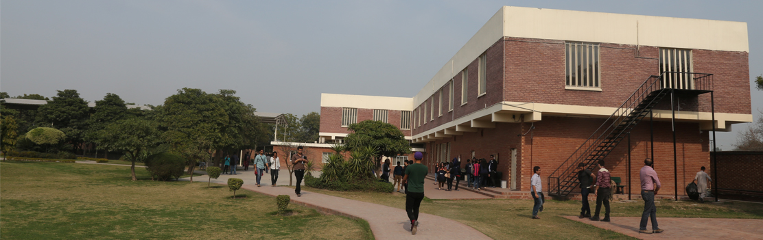

**Home People Research Prospective Students Events News & Media Contacts Us**

Faculty Centers  Undergraduate Programs Forthcoming Seminars News

 Researchers CREB *Post-Graduate Programs* External Events *Media*

 Graduate Students GIDS *Economics Department Collaborations*

 Technology Management & Innovation Centre  Past Events

Working Papers Annual Conference 2016

 CREB Working Papers  Annual Conference 2015

 *Publications*   Annual Conference 2014

 Lahore Journal of Economics (LJE)

 Economics Department Recent Publications

**QUICK LINKS PROSPECTIVE STUDENTS Useful Links STAY CONNECTED**

* [About Us](http://www.economics.ox.ac.uk/About-Us/about-us) Undergraduate *Programs*  Lahore School of Economics Facebook
* [Contact Us](http://www.economics.ox.ac.uk/index.php?option=com_contact&Itemid=230&id=53&lang=en&view=contacts) *Post-Graduate Programs* CREB LinkedIn
* [Degree](http://www.economics.ox.ac.uk/About-Us/finding-us) Programs GIDS Twitter
* LJE Instagram
* Lahore School of Economics Blog